Equating Real and Imaginary Parts

Example 1

Find the values of a and b if 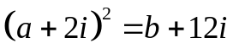

Example 2

Find the square roots of 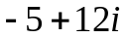

Example 3

Solve the following equation to find z

